1. 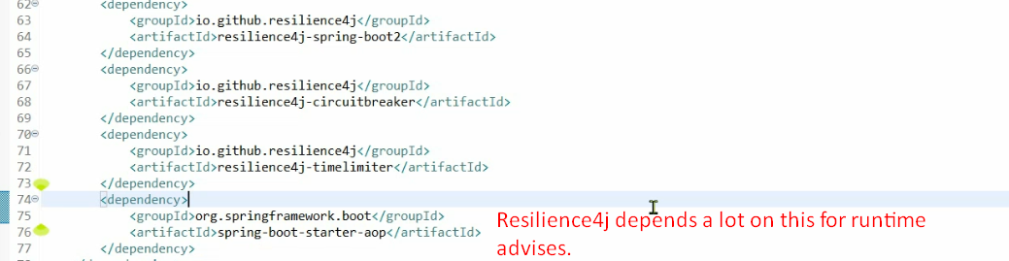
2. @**CircuitBreaker**:
   1. To implement circuit breaker pattern.
   2. Can be applied on end-point methods level or service level.
   3. We give it a name so that we know which the circuit is that has an issue.
   4. As soon as you add this annotation, you need to add some configurations to application.properties to override default configuration.
3. 